Using Lomaps England and Lomaps France North

Attempt to Navigate

To

Camp site
N 50° 51.775', E 001° 38.974'
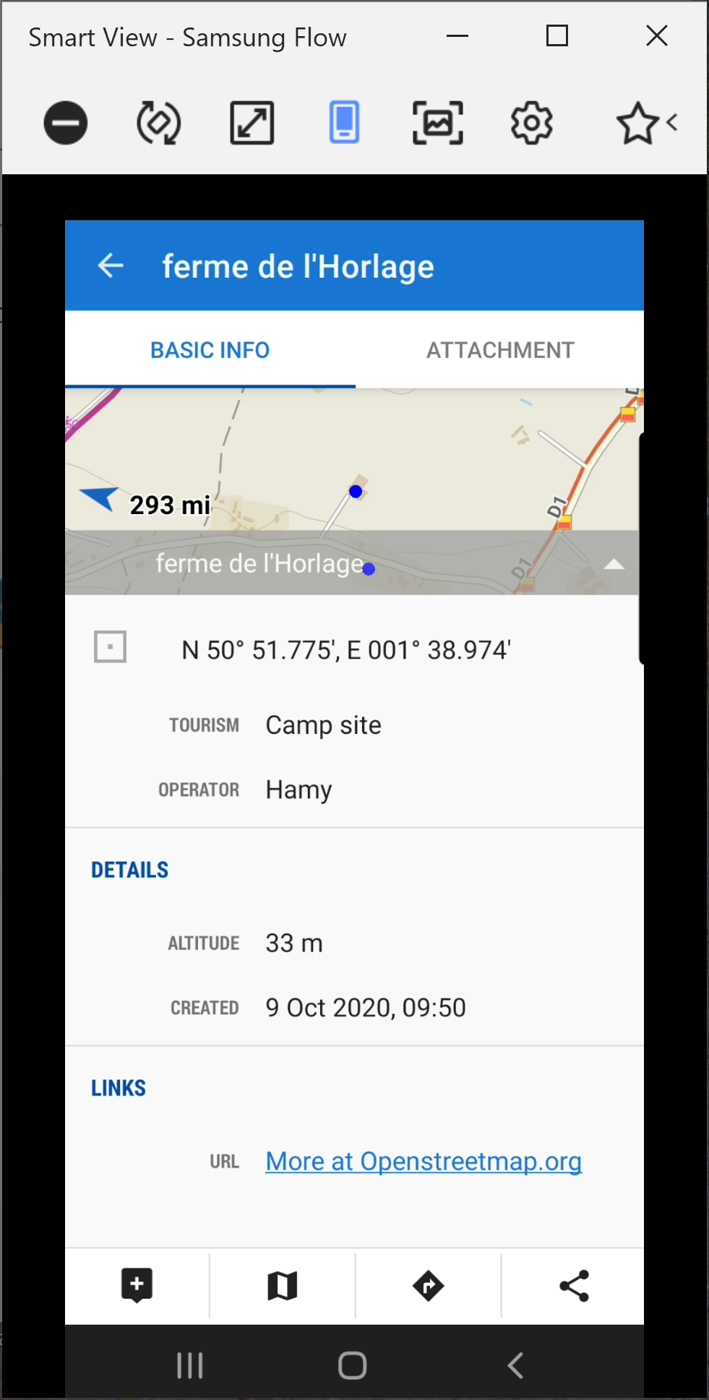

From

N 51° 05.424', E 001° 07.783'
Supermarket

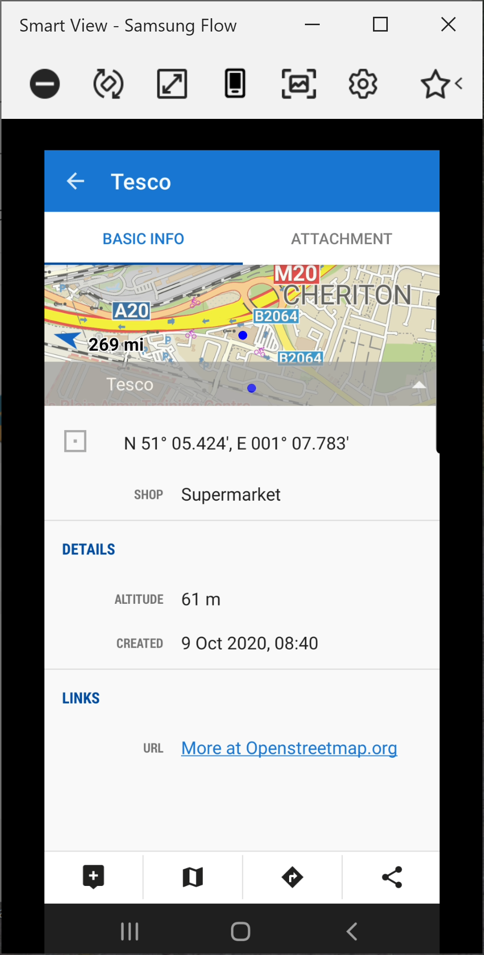

I use Brouter (Because of offline use)
Locus Profile
Fast
Routing Profile
Car-Fast
Parameters
None selected

Even though the Channel tunnel is closer to both from and to points, it will navigate past it to select the ferry.

Same Navigation using GraphHopper as suggested.
Selected Avoid Ferries

This message appears

Sorry too long route to calculate try a shorter one

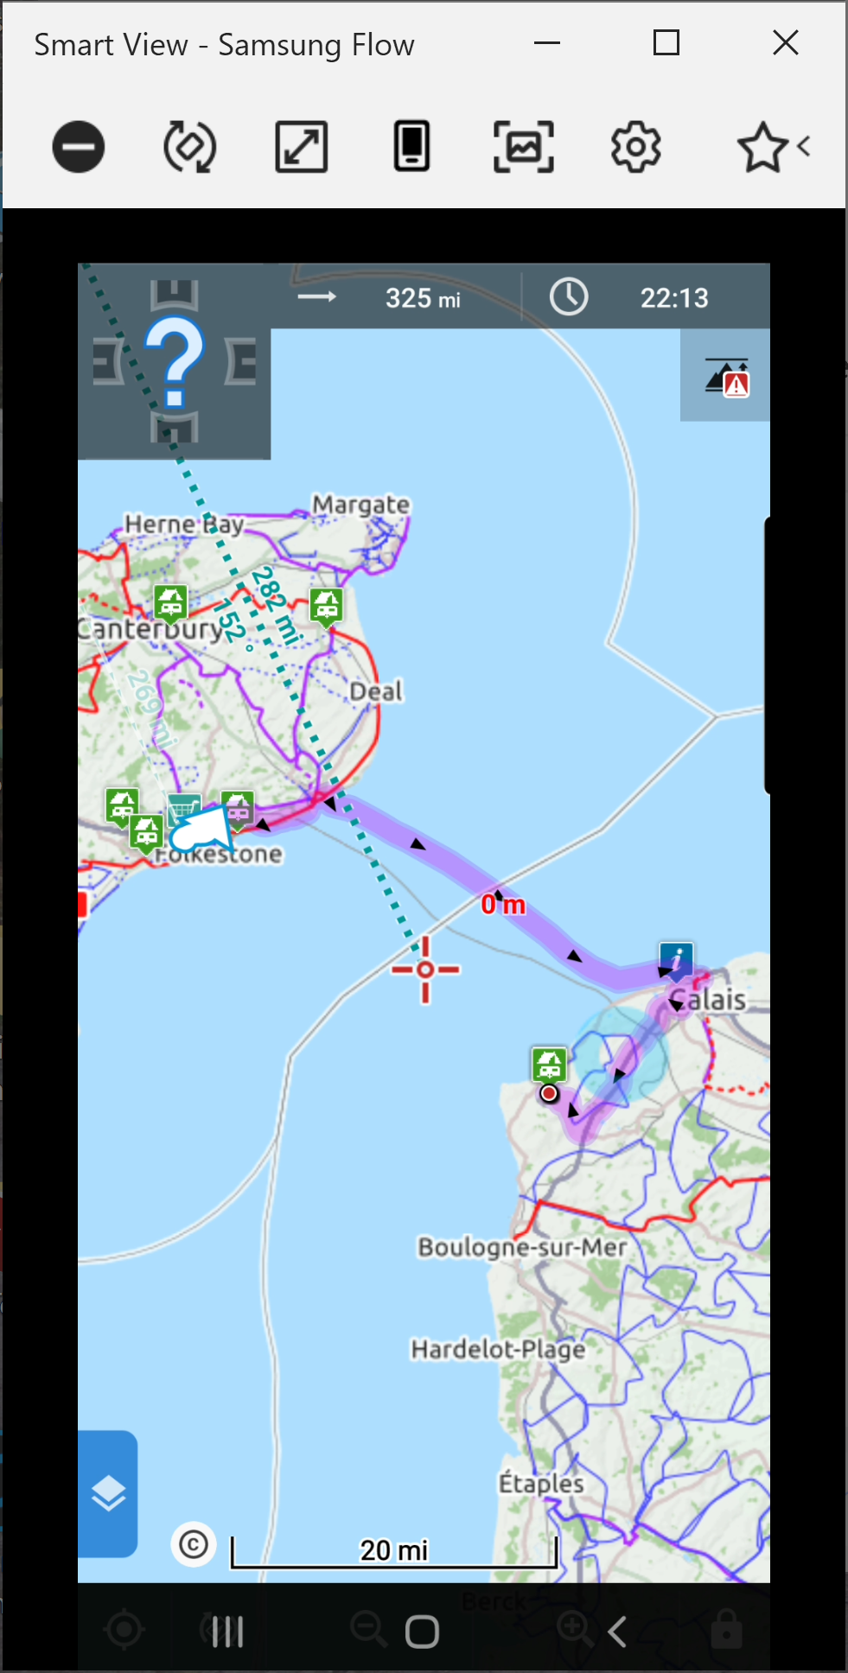

It appears that Locus has no knowledge of the Channel Tunnel existing.

