By Andrew: Want to see more ‘distinct’ colors especially around the important Red ascend zone.

Locus Color Palette: Natural color order, but shows very little color shift around Red (ascend) zone.
Orux Color Palette: +/- similar colors. And Green center color range is very small. What is it good for ?

Test by: http://www.efg2.com/Lab/ScienceAndEngineering/Spectra.htm (download program zip)

Natural Color rainbow spectrum by wavelenght shows very slow color shift around Red. RGB:255/0/0
Green Color: Is out of center in the visible spectrum by wavelenght linear scale.

I created (manualy) a 17 distinct color palette, in correct natural order out of that rainbow spectrum.
Center color: Green.

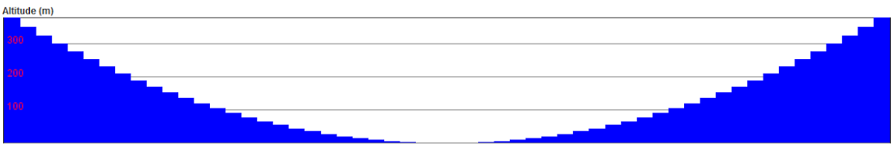
-29% 0% +29%

Gps Track Editor. (pc) (29%)

Locus Map Palette.(29%)

17 Natural Color Palette. (-8/0/+8)

Orux Map Palette.(25%)
